COSC 589 - Web Search and Sense-Making

Assignment 1

Part A:

Code:

object StateDiagram {

def main(args: Array[String]){

val states = List("carzy","blue sky","jump","free fall","parachute","alive","dead","cloudy")

var myState = ""

println("I have a friend")

println("Sometimes she is " + states(0))

print("When it is ")

var r = scala.util.Random

var chance = r.nextInt(100)

if (chance >= 50){

myState = states(7)

println(myState)

println("She is " + states(5))

}

else{

myState = states(1)

println(myState)

println("She " + states(2))

var chance1 = r.nextInt(100)

var r1 = scala.util.Random

if(chance1 < 30){

println("She uses " + states(4))

println("She is " + states(5))

}

else{

println("She " + states(3))

var r2 = scala.util.Random

var chance2 = r.nextInt(100)

if(chance2 < 80 ){

println("She uses " + states(4))

println("She is " + states(5))

}

else{

println("She is " + states(6))

}

}

}

}

}

Screen capture:

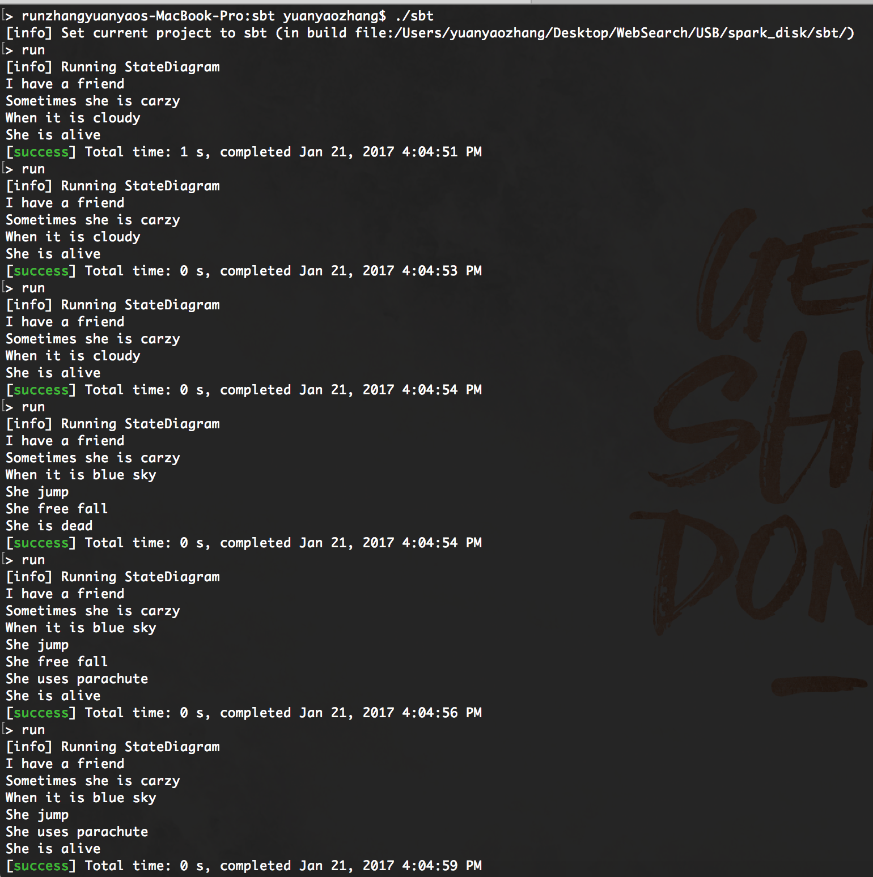

Part B:

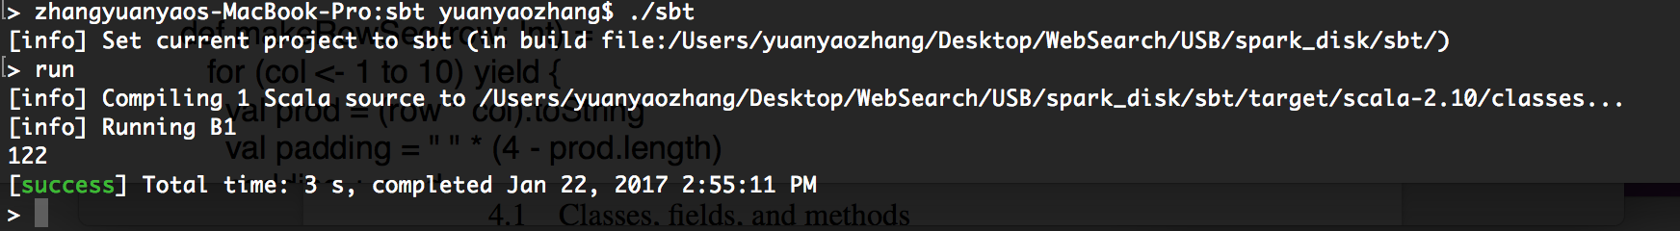

Output: 122

2+ 1+2+…+15 = 2 +120 = 122

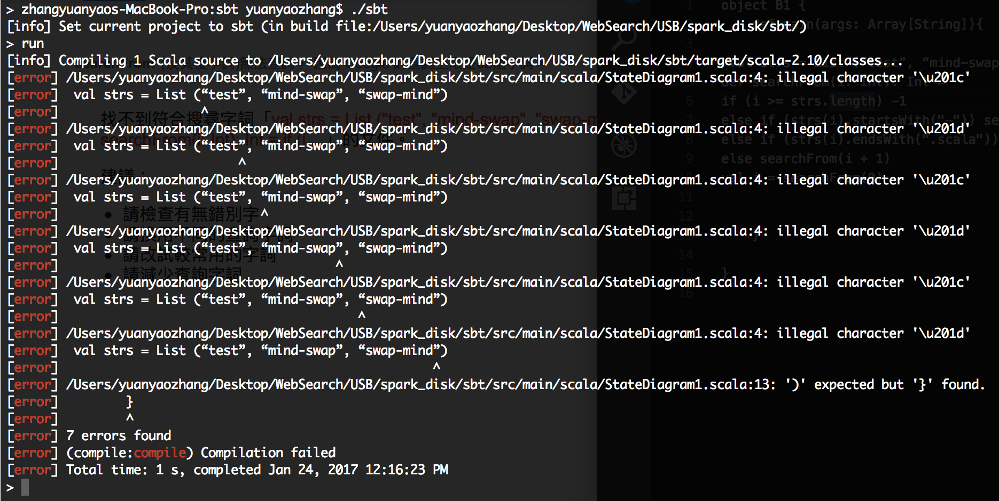

There is no output for original script, so I print i by myself. And the format of the quote is incorrect, so I modify myself.

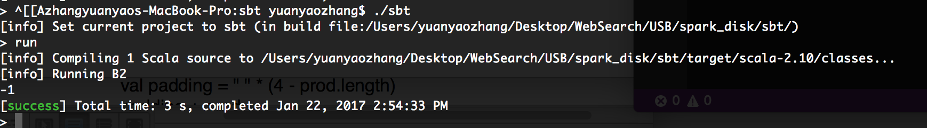

Output: i = -1

The val i start with 0. In the strs List there is no word end with “.scala” and start with a “-”, that , means there will be no condition which satisfy the both else if.

So the first three loop will in the condition of “else searchFrom(i+1)” until the i = 3 which satisfy the “if (i >= strs.length) -1” and break the loop.

The output of i = -1.

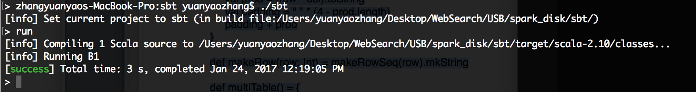There is no output for original script, so I print multiTable by myself.

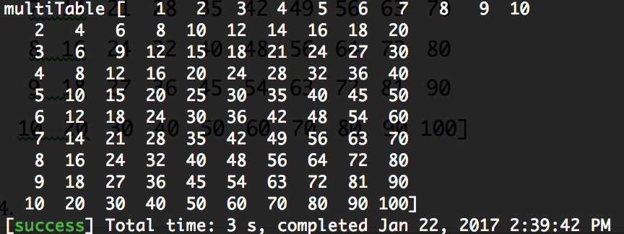

Output: Print the multiTable

multiTable

[ 1 2 3 4 5 6 7 8 9 10

2 4 6 8 10 12 14 16 18 20

3 6 9 12 15 18 21 24 27 30

4 8 12 16 20 24 28 32 36 40

5 10 15 20 25 30 35 40 45 50

6 12 18 24 30 36 42 48 54 60

7 14 21 28 35 42 49 56 63 70

8 16 24 32 40 48 56 64 72 80

9 18 27 36 45 54 63 72 81 90

10 20 30 40 50 60 70 80 90 100]

When executing the row = 1, it runs the line “makeRow(1)” which means run the def makeRowSeq(1) as string.

For the function makeRowSeq() it start form col = 1, prod = 1 * 1 then to string type. prod.length = 1 which make padding as “ ” * (4-1) = “ ” * 3. That means there will be three blanks before prod as “ 1”. When the number reach two double digits, the prod.length will be 2, so the blanks in front of prod will change into 2. Ex. “ 10”.

Base on above will make the first row as

“ 1 2 3 4 5 6 7 8 9 10”.

For the result of row from 2 to 10 will be the same logic which leads to the output above.

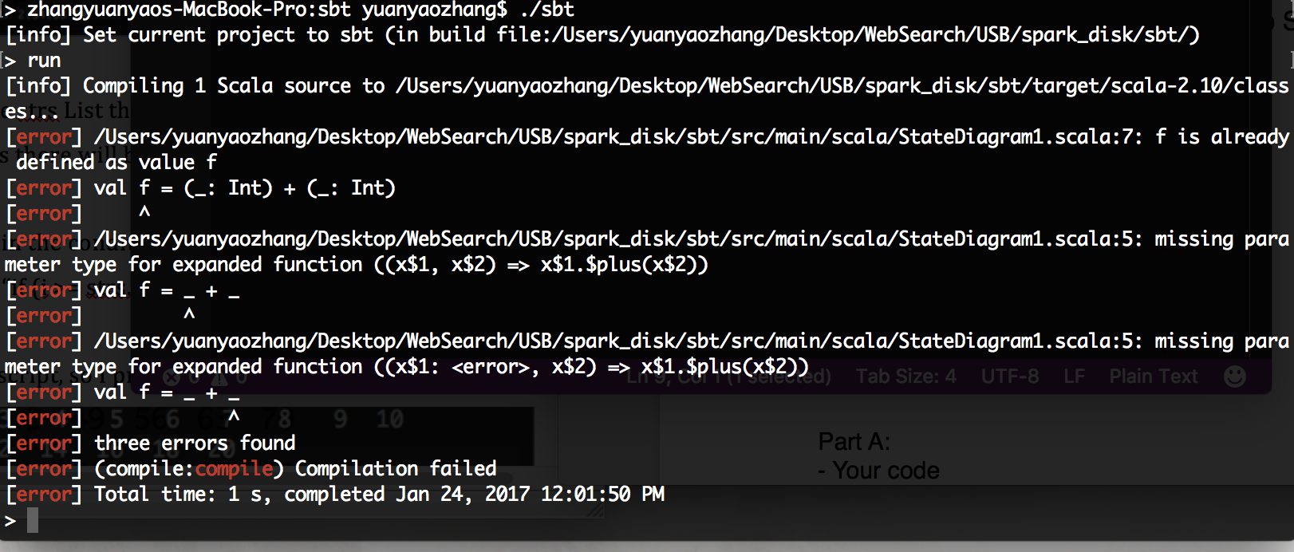

The code has an error on the first line, because “_” mean as previous input and there is no previous input for the first ”f”.

After deleting the first line, assigned an value to f(). It prints out value 15. Which mean f = 5 + 10.

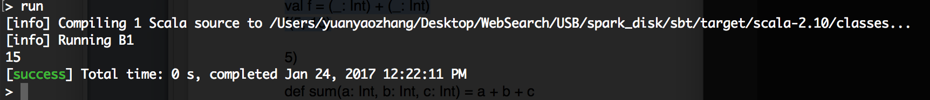

1. Output:

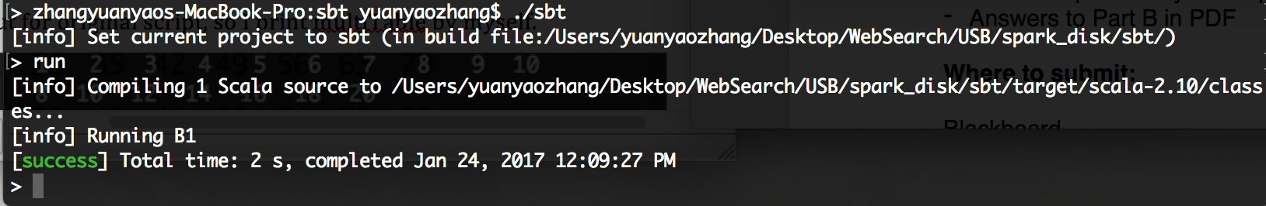

First def the function sum as integer a + b + c, then declare a val a and send it into the function sum by using a = 1, b = 2, c =9. So if I modify the code as “val O = a(1, 2, 9)” , then print out “O” the output will be 12.